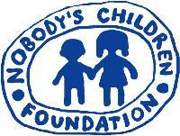

REGISTRATION FORM

“European migrant children: what protection?”
Launch of Research “Vulnerability to exploitation and trafficking of
Bulgarian children and adolescents in Greece”

26 May 2011 - BRUSSELS
European Parliament
9.00 – 13.30 - Room 6Q1

Family Name
First name
Date of Birth
Nationality
Type of identity document (ID, Passport)
Number of Identity document
Organization

The event is free. Places are limited. To attend please send this registration form before 13 May 2011 to tdh-europe3@terredeshommes.org and tdh-europe@iftdh.org The working languages of the conference will be English and French. For any question or more information, contact Giang Cao, Communication and Advocacy Officer, Terre Des Hommes,
tdh-europe@iftdh.org , phone: +32 2 8930951



